***Image Enhancement Methods***

Peicheng Wen

Troy University

[wenpc110@gmail.com](mailto:wenpc110@gmail.com)

***Abstract -* The aim of image enhancement is to process an image to make it more suitable for the acquire case. The image enhancement algorithms provide the ways to improve the visual quality of images. The previous algorithm: Histogram Equalization has some limited problems. In his paper we created a new algorithm and did the comparison between these two methds.**

***Keywords - Image Enhancement, Digital Image Processing, Point Processing, Histogram Processing***

* 1. introduction

Image processing is becoming more and more important because of the rapid development of the colorful display devices, such as smart phones, TVs and other devices which have screens. One of the most important parts in Image processing is colorful image enhancement. The reason is because the connection and information transportation between multi-devices are much more mentioned these days. In spatial domain techniques [1], we directly deal with the image pixels. The pixel values are manipulated to achieve desired enhancement. We have some common methods to do the image enhancement these days. One of those is histogram equalization. However it cannot solve all the problems there are some cases we cannot use Histogram equalization. So in this project, I created a new algorithm to do the image enhancement.

* 2. Previous algorithm

Histogram equalization [5] is a common technique for enhancing the appearance of images. Suppose we have an image which is predominantly dark. Then its histogram would be skewed towards the lower end of the grey scale and all the image detail is compressed into the dark end of the histogram. If we could ‘stretch out' the grey levels at the dark end to produce a more uniformly distributed histogram then the image would become much clearer.

* 3. Problems of previous algorithm.



Pic1 Original Image

Because of the condition and environment of photography, sometimes we cannot get the satisfactory photos. Like the Pic1, we can only see a lightening there while it`s hard to distinguish the details of other parts. So the problem is how to make the images whose most pixel values are similar and low. We need to deal with the pictures which are too dark.

Proposed method

There is a common method called Histogram Equalization which can be effective in Image Enhancement area. Wikipedia: “Histogram equalization is a method in image processing of contrast adjustment using the image's histogram.” Histogram Equalization increases the global contrast of the images.

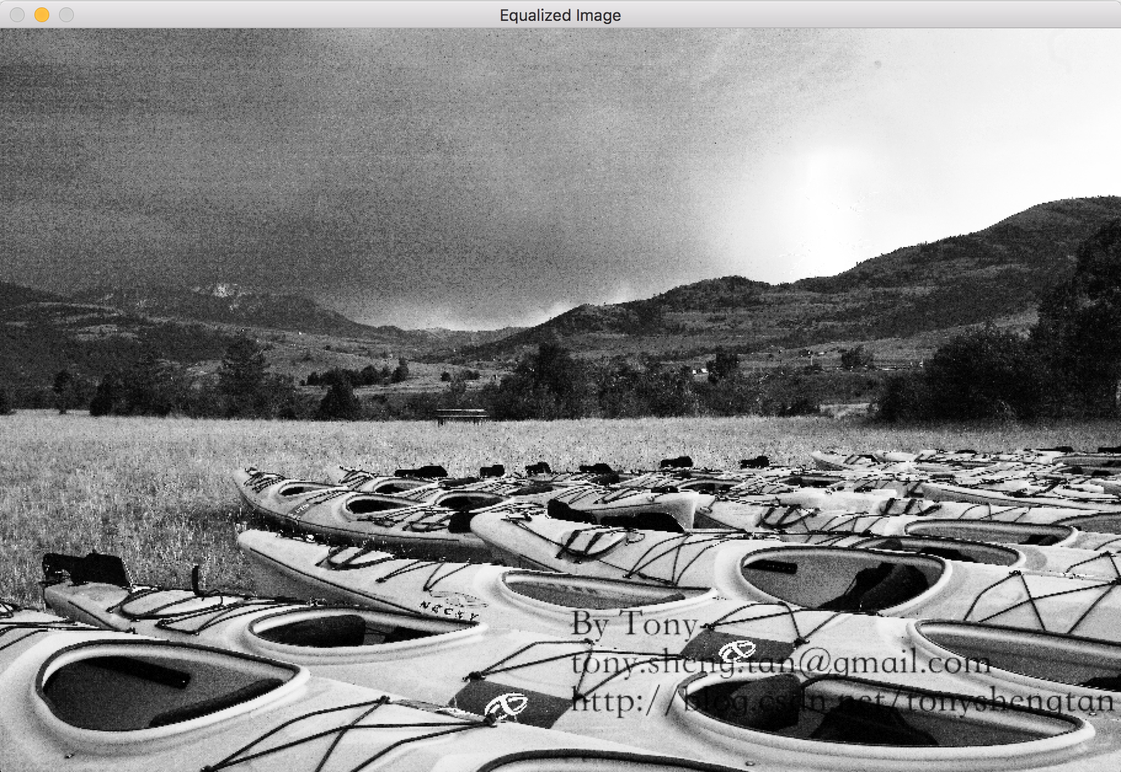



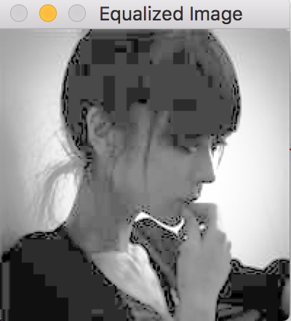



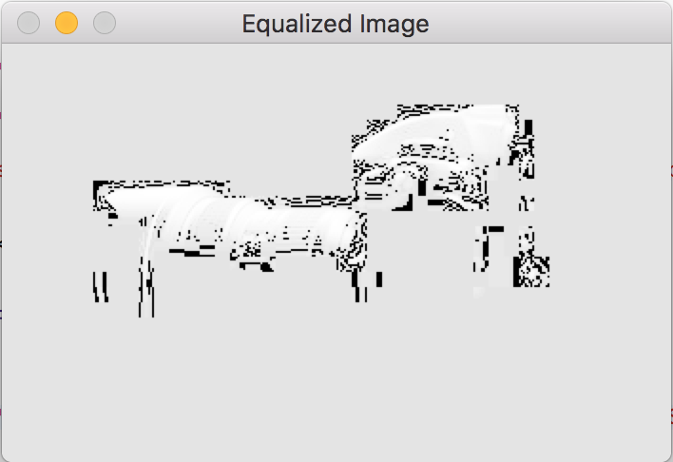

We can see the result of equalized problem above. When we use the histogram method it makes the whole mage brighter and loses many details in high value scale. This method usually increases the global contrast of many images, especially when the usable data of the image is represented by close contrast values. The method is useful in images with backgrounds and foregrounds that are both bright or both dark. A disadvantage of the method is that it is indiscriminate. It may increase the contrast of background noise, while decreasing the usable signal.

* 4. Proposed algorithm

I based on these three points to create the method:

Deal with the scale which we focus on

Manipulate the values of single pixel differently

Try to show more details of dark image without changing the feature of the image obviously

* 5. Formula

$$P_{new}\left(v\right)=a*P_{original}(v)$$

$a$ increases while $P_{original}(v)$ increases

code part:

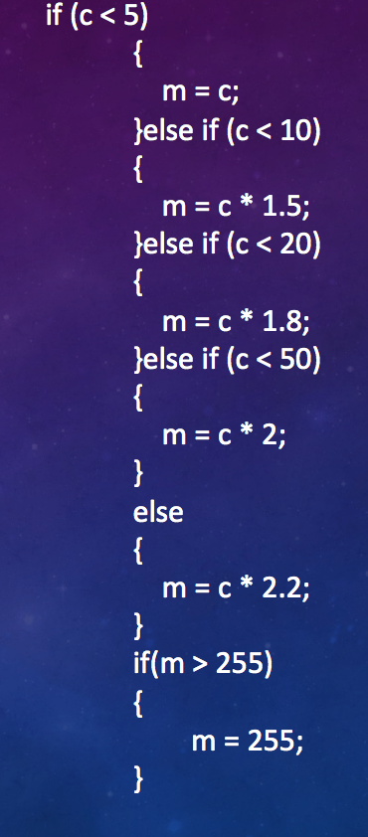

* 6. Simulation and comparison





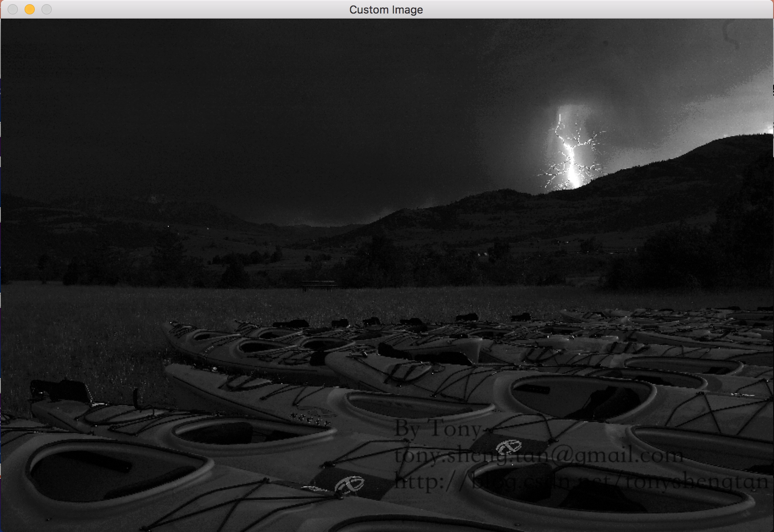

We can see our method can show more details while keeping the general features of original pictures. We can see the lightening in new method while there is not in equalized image.







We can see that the new method has less noise in this picture while the histogram method enhances noise and useful information together. And the new method can still show more details than the original image. We can see more clearly through new method.







This image we cannot use histogram method to do the enhancement. But our method can still do effective work here.

* 7. Conclusion

New Method is able to be an effective way to enhance images. New Method performs better than Histogram in certain images. New Method can both show the details of dark component and keep the general feature of the original image.

However, the new method also has some limitation. It can not deal with the details when the value of pixel is high.

* 8. Future work

We still have some problems in this method. Like we did not discuss how to set the coefficient more effectively. We still need to optimize the algorithm to solve the problem in high value scale and do more work on how to make the coefficient more reasonable in different cases.

**References**

[1] Bhabatosh Chanda and Dwijest Dutta Majumder, 2002, Digital Image Processing and Analysis.

[2] Kuei-Chun Chen, Color Image Enhancement.

[3] Chochia, P.A., Image enhancement using sliding histogram,1988

[4] Scollar, I. and Weinder, B., Image enhancement using the median and the inter quartile diatance, 1984.

[5] J.C. Russ, The Image Processing Handbook, CRC Press,Boca Raton, FL., 1992.

[6] J. Canny (1986), A computational approach to edge detection, IEEE Trans. on Pattern

Analysis and Machine Intelligence, Vol. 8, No. 6 (Nov 1986)679-698.

[7] Levent Karacan, Erkut Erdem, Aykut Erdem, Structure-Preserving Image Smoothing via Region Covariances

[8] Raman Maini and Himanshu Aggarwal, A Comprehensive Review of Image Enhancement Techniques. MARCH 2010, ISSN 2151-9617